**VISVESVARAYA TECHNOLOGICAL UNIVERSITY, BELGAUM**

“Jnana Sangama”, Belgaum-590018

****

**A Report On**

**“HOSPITAL APPPOINTMENT SYSTEM”**

Submitted by

**SWASTHIK S NETTAR 4NI19IS102**

**TEJASVINI S J 4NI19IS106**

**SHIVANI L H 4NI19IS089**

Under the Guidance of

**Ms. Prathibha.B.S Faculty**

Assistant Professor **Shwetha.G.N and Monika.Nag.K.J**

**Dept of IS&E** Assistant Professors

**NIE, Mysuru Dept of IS&E**

**NIE, Mysuru**

****

**The National Institute of Engineering Department of Information and Engineering**

**MYSURU-570008 MYSURU-570008**

**2020-2021**

**THE NATIONAL INSTITUTE OF ENGINEERING**

**MYSURU-570008**

**Department of Information Science and Engineering**

|  |  |
| --- | --- |
|  | **D:\Documents and Settings\Chandan\Desktop\WhatsApp_files\pp_013.jpg** |

**CERTIFICATE**

Certifies that the project work titled “**HOSPITAL APPPOINTMENT SYSTEM**” is a work carried out by **SWASTHIK S NETTAR(4NI19IS102), TEJASVINI S J (4NI19IS106)** and **SHIVANI L H(4NI19IS089)**

in partial fulfilment for the requirements of the fourth semester BE in Information Science & Engineering prescribed by The National Institute of Engineering, Autonomous Institution under Visvesvaraya Technological University, Belagavi. It is certified that all corrections/suggestions indicated for Internal Assessment have been incorporated. The Project report has been approved as it satisfies the academic requirements in respect of the project work prescribed for the fourth semester in Data Base Laboratory.

Signature of Guides Signature of HOD Signature of Principal

(Dr. P.Devaki) (Dr. N.V.Raghavendra)

Name of the Examiner Signature with Date

1. Shwetha.G.N
2. Monika.Nag.K.J

**ABSTRACT**

Every person who has to book an appointment in GP or hospital before their visit to organization (unless in emergency). The web-based appointment booking system simplifies the date, time, and choice of doctor, changing or modifying patient details. Since the internet has become an important part of our lives, organizations either small businesses or big establishments make it part of their business functionalities. The technology is expanding day by day and online sources are also increasing too.

The online system has transformed complete background of information exchange. This research is also related to develop of web-based appointment booking system where user only has to type URL provided and they can access it from anywhere in the world and any time. The system will allow patient to log register.

The system will reduce burden of workload of their staff and staff will be more efficient. The research will carry before start developing a system it will help to choose right tools, technologies.

The use of web-based appointment booking system will allow customer to book appointment anytime for example if they want to book appointment at midnight so they will be able to make it without waiting for GP to open in morning and then call to GP because telephone booking appointment system will work only when GP is open but web based appointment booking system will work all the time 365 days in a year.

**ACKNOWLEDGEMENT**

The success and the final outcome of this project required a lot of guidance and assistance from many people and we are extremely fortunate to have got this all along the completion of project work.

We express our profound thanks to **Dr. N.V.Raghavendra*,*** Principal, NIE, Mysuru for his much-needed moral support and encouragement.

We are grateful to **Dr. P.Devaki*,*** Prof.& H.O.D., Information Science and Engineering, NIE for her support and encouragement in facilitating the progress of this work.

We sincerely extend our thanks to our project Guides **Ms. Prathibha.B.S, Ms. Shwetha.G.N and Ms. Monika.Nag.K.J** Assistant Professor in the Dept. of I.S.&E., for their guidance, technical expertise, encouragement and timely help in making this project a reality.

Also, we would like to extend our sincere regards to all the non-teaching staff of the IS&E Dept. for their timely support.

**SWASTHIK S NETTAR 4NI19IS102**

**TEJASVINI S J 4NI19IS106**

**SHIVANI L H 4NI19IS089**

**TABLE OF CONTENTS**

**Sl. No. Chapter Page No.**

1. Introduction 6

2.Proposed System 7

3.Database Design 9

4.System Design 11

5. Implementation 21

**CONCLUSION** 26

**FUTURE ENHANCEMENTS** 26

**REFERENCES** 26

**Chapter1**

**INTRODUCTION**

Our project title is 'Hospital Appointment System'. In which a patient can book their respective appointment with a particular doctor with different specializations at a scheduled time, all while not having to make the effort of going out of our homes to book an appointment nor rely on calls, when now we can book an appointment at our leisure time.

Our main goal in this project was to create a database system in which people have easy access to schedule their choice of health check-up by making an appointment online.

In this project, our target is to develop of database management system for Hospital appointments.

This system benefits the potential patients with its detailed report on the doctors, their specialization, their appointments schedules and for better understanding of the management procured by the system.

Our project also contains a registration page where the patients can register their details when entering the site and further book the appointment. Although we need to make further adjustments with the webpage and include more details as well as features in the future.

**Chapter 2**

**PROPOSED SYSTEM**

**DESIGN:**

As discussed above, the web application is majorly made using PHP, the details of which are given below.

**Cascading Style Sheets (CSS):**

Cascading style sheets (CSS) is a style sheet language used for describing the presentation of a document written in a markup language. Although most often used to set the visual style of web pages and user interface written in HTML and XHTML, the language can be applied to any XML document, including plain XML, SVG and XUL, and is applicable to reading in speech or on other media.

**HTML:**

The Hypertext Markup Language, or HTML is the standard markup language for documents designed to be displayed in a web browser. It can be assisted by technologies such as Cascading Style Sheets (CSS) and scripting languages such as JavaScript. Web browsers receive HTML documents from a web server or from local storage and [render](https://en.wikipedia.org/wiki/Browser_engine) the documents into multimedia web pages. HTML describes the structure of a web page semantically and originally included cues for the appearance of the document.

**PHP:**

PHP is a server-side scripting language. that is used to develop Static websites or Dynamic websites or Web applications. PHP scripts can only be interpreted on a server that has PHP installed. The client computers accessing the PHP scripts require a web browser only.

**XAMPP:**

XAMPP is an open-source web server package that works on various platforms. It is actually an acronym with X meaning “cross” platform, A for Apache HTTP server, M for MySQL, P for PHP, and P for Perl. XAMPP may be used to stand as pages for the internet even without connection to it. It can also be used to create and configure databases written in MySQL and/or MariaDB. And since XAMPP is designed as a cross-platform server package, it is available for a variety of operating systems and platforms like Microsoft Windows, Mac OS X, Linux, and Solaris.

**Hardware requirements:**

1.Processor: 10th Gen Intel Core i5 and above

2.Memory: 4 GB and above

3.Disc space: 20 GB (3 GB for database files + enough GB for shared documents, individual)

**Software requirements:**

1. Windows OS

2. MySQL

3. XAMPP

4.PHPmyadmin

5. Visual Studio Code

**Chapter 3**

**DATABASE DESIGN**

**Schema Diagram:**

**ER Diagram:**

**Chapter 4**

**SYSTEM DESIGN**

**Creating database and tables:**

create database DBS;

use DBS;

create table doctor\_specialisation( id integer primary key,specialisation\_in varchar(30));

create table DOCTOR(id integer primary key,first\_name varchar(30),last\_name varchar(30),phone\_number bigint(10),

email varchar(30),specialisation\_id integer);

alter table DOCTOR add foreign key(specialisation\_id) references doctor\_specialisation(id);

create table doctor\_availability(id integer primary key,doctor\_id integer,days\_in\_week varchar(10),starting\_time timestamp,ending\_time timestamp,open\_for\_day varchar(3),

minutes\_per\_patient integer);

alter table doctor\_availability add foreign key(doctor\_id) references doctor(id);

create table insurance\_provider(id integer primary key,provider\_name varchar(30),phone\_number bigint(10),email varchar(20));

create table patient\_details(id integer primary key,first\_name varchar(30) ,last\_name varchar(30),phone\_number bigint(10),email varchar(20),insurance\_provider\_id integer,

insurance\_id varchar(20),mailing\_address varchar(20));

alter table patient\_details add foreign key(insurance\_provider\_id) references insurance\_provider(id);

create table appointment\_status(id integer primary key,status varchar(10),created\_date date);

create table appointment(id integer primary key,doctor\_id integer,patient\_id integer,appointment\_status\_id integer,start\_time timestamp,end\_time timestamp,

comment\_by\_patient varchar(400),comment\_by\_doctor varchar(400));

alter table appointment add foreign key(doctor\_id) references doctor(id);

alter table appointment add foreign key(patient\_id) references patient\_details(id);

alter table appointment add foreign key(appointment\_status\_id) references appointment\_status(id);

**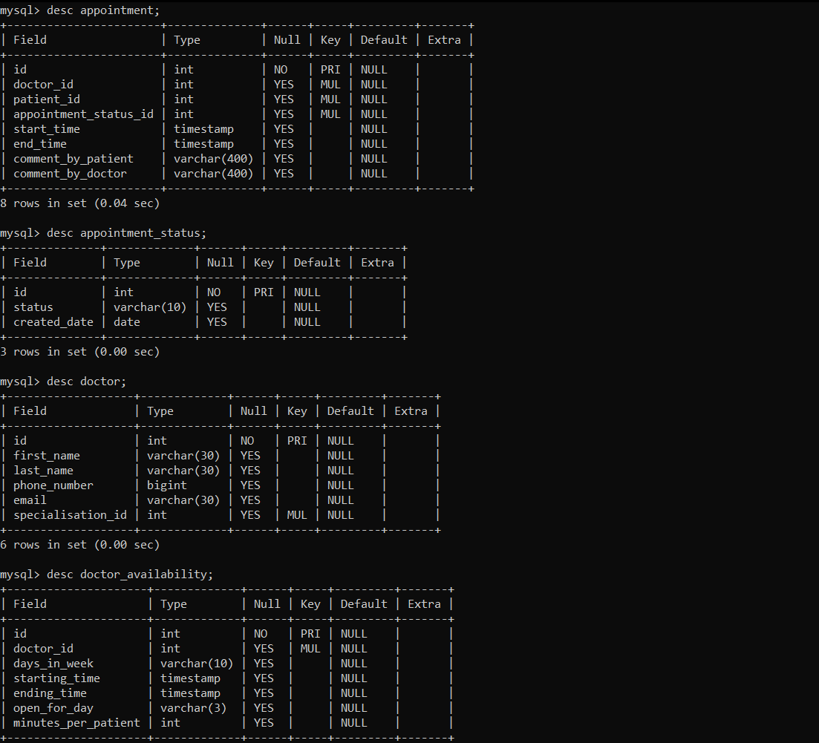**

**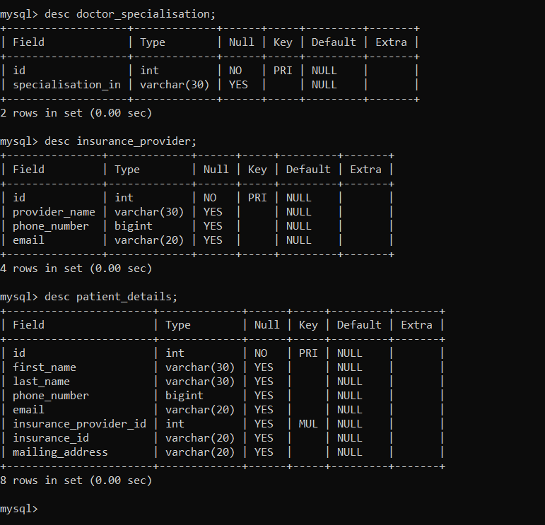**

**Inserting data into the tables :**

insert into appointment\_status (id,status,created\_date) values( 1,'Confirmed','2009-12-01');

insert into appointment\_status (id,status,created\_date) values( 2,'Cancelled','2009-12-01');

insert into appointment\_status (id,status,created\_date) values( 3,'Pending','2009-12-01');

insert into doctor\_specialisation (id,specialisation\_in) values (1,'General Medicine');

insert into doctor\_specialisation (id,specialisation\_in) values (2,'Allergy and Immunology');

insert into doctor\_specialisation (id,specialisation\_in) values (3,'Surgeon');

insert into doctor\_specialisation (id,specialisation\_in) values (4,'Gynecologists');

insert into doctor\_specialisation (id,specialisation\_in) values (5,'Neurology');

insert into insurance\_provider(id,provider\_name,phone\_number,email) values (1,'United Insurance',9898987865,'united@xyz.com');

insert into insurance\_provider(id,provider\_name,phone\_number,email) values (2,'Med Life Insurance',8765432096,'medlife@xyz.com');

insert into insurance\_provider(id,provider\_name,phone\_number,email) values (3,'Stanford Insurance',9807654324,'stanford@xyz.com');

insert into doctor(id,first\_name,last\_name,phone\_number,email,specialisation\_id) values(1,'Steve','John',8765421321,'steve@xyz.com',1);

insert into doctor(id,first\_name,last\_name,phone\_number,email,specialisation\_id) values(2,'Robert','Jacob',8909812345,'robert@xyz.com',2);

insert into doctor(id,first\_name,last\_name,phone\_number,email,specialisation\_id) values(3,'Brian','Flair',7890865765,'brian@xyz.com',3);

insert into doctor(id,first\_name,last\_name,phone\_number,email,specialisation\_id) values(4,'Seth','Dolph',9806543212,'seth@xyz.com',4);

insert into doctor(id,first\_name,last\_name,phone\_number,email,specialisation\_id) values(5,'Dean','Stuart',8954312098,'dean@xyz.com',5);

insert into doctor\_availability(id,doctor\_id,days\_in\_week,starting\_time,ending\_time,open\_for\_day,minutes\_per\_patient) values

( 1,1,'Monday','2009-12-01 08:00:00','2009-12-01 18:00:00','Yes',30);

insert into doctor\_availability(id,doctor\_id,days\_in\_week,starting\_time,ending\_time,open\_for\_day,minutes\_per\_patient) values

( 2,2,'Friday','2009-12-05 10:30:00','2009-12-05 16:00:00','Yes',30);

insert into doctor\_availability(id,doctor\_id,days\_in\_week,starting\_time,ending\_time,open\_for\_day,minutes\_per\_patient) values

( 3,3,'Tuesday','2009-12-02 13:00:00','2009-12-02 15:30:00','Yes',30);

insert into doctor\_availability(id,doctor\_id,days\_in\_week,starting\_time,ending\_time,open\_for\_day,minutes\_per\_patient) values

( 4,4,'Wednesday','2009-12-04 08:00:00','2009-12-04 18:00:00','Yes',30);

insert into doctor\_availability(id,doctor\_id,days\_in\_week,starting\_time,ending\_time,open\_for\_day,minutes\_per\_patient) values

( 5,5,'Saturday','2009-12-07 09:30:00','2009-12-07 16:35:00','Yes',30);

insert into doctor\_availability(id,doctor\_id,days\_in\_week,starting\_time,ending\_time,open\_for\_day,minutes\_per\_patient) values

( 6,5,'Friday','2009-12-05 09:30:00','2009-12-05 16:35:00','Yes',30);

insert into patient\_details(id,first\_name,last\_name,phone\_number,email,insurance\_provider\_id,insurance\_id,mailing\_address) values(1,'Mark','Wahlberg','7655432109','mark@xyz.com',1,'5678','abcd');

insert into patient\_details(id,first\_name,last\_name,phone\_number,email,insurance\_provider\_id,insurance\_id,mailing\_address) values(2,'John','Snow','9012345432','john@xyz.com',2,'9088','qwert');

insert into patient\_details(id,first\_name,last\_name,phone\_number,email,insurance\_provider\_id,insurance\_id,mailing\_address) values(3,'Goerge','Wick','7123456091','george@xyz.com',3,'4568','rstu');

insert into patient\_details(id,first\_name,last\_name,phone\_number,email,insurance\_provider\_id,insurance\_id,mailing\_address) values(4,'Parker','Kyle','9216734058','parker@xyz.com',1,'1201','bcnm');

insert into patient\_details(id,first\_name,last\_name,phone\_number,email,insurance\_provider\_id,insurance\_id,mailing\_address) values(5,'King','Chloe','7123456081','king@xyz.com',2,'0967','adfg');

insert into patient\_details(id,first\_name,last\_name,phone\_number,email,insurance\_provider\_id,insurance\_id,mailing\_address) values(6,'Richard','Joey','9671267891','richard@xyz.com',3,'8765','lkop');

insert into patient\_details(id,first\_name,last\_name,phone\_number,email,insurance\_provider\_id,insurance\_id,mailing\_address) values(7,'Bill','Benz','8012670987','bill@xyz.com',2,'2569','poiu');

insert into patient\_details(id,first\_name,last\_name,phone\_number,email,insurance\_provider\_id,insurance\_id,mailing\_address) values(8,'Stan','Ford','7123450985','stan@xyz.com',1,'3254','jklo');

insert into patient\_details(id,first\_name,last\_name,phone\_number,email,insurance\_provider\_id,insurance\_id,mailing\_address) values(9,'Nulan','Lord','9078904596','nulan@xyz.com',3,'1478','dfgh');

insert into patient\_details(id,first\_name,last\_name,phone\_number,email,insurance\_provider\_id,insurance\_id,mailing\_address) values(10,'Ash','Rant','7655432108','ash@xyz.com',3,'9632','asdf');

insert into appointment(id,doctor\_id,patient\_id,appointment\_status\_id,start\_time,end\_time,comment\_by\_patient,comment\_by\_doctor) values

(1,1,1,1,'2009-12-01 08:30:00','2009-12-01 09:00:00','Fever','Paracetamol\_drug');

insert into appointment(id,doctor\_id,patient\_id,appointment\_status\_id,start\_time,end\_time,comment\_by\_patient,comment\_by\_doctor) values

(2,1,2,1,'2009-12-01 12:30:00','2009-12-01 13:00:00','Cold','Afrin\_drug');

insert into appointment(id,doctor\_id,patient\_id,appointment\_status\_id,start\_time,end\_time,comment\_by\_patient,comment\_by\_doctor) values

(3,2,4,1,'2009-12-05 12:40:00','2009-12-05 13:10:00','Allergy','Cetirizine\_drug');

insert into appointment(id,doctor\_id,patient\_id,appointment\_status\_id,start\_time,end\_time,comment\_by\_patient,comment\_by\_doctor) values

(4,2,3,1,'2009-12-05 14:00:00','2009-12-05 14:30:00','Diabetes','Insulin\_drug');

insert into appointment(id,doctor\_id,patient\_id,appointment\_status\_id,start\_time,end\_time,comment\_by\_patient,comment\_by\_doctor) values

(5,3,7,1,'2009-12-02 13:00:00','2009-12-02 13:30:00','Pain in heart','Surgery\_recommended');

insert into appointment(id,doctor\_id,patient\_id,appointment\_status\_id,start\_time,end\_time,comment\_by\_patient,comment\_by\_doctor) values

(6,4,6,1,'2009-12-04 10:00:00','2009-12-04 10:30:00','Infertility','Can go with IVF');

insert into appointment(id,doctor\_id,patient\_id,appointment\_status\_id,start\_time,end\_time,comment\_by\_patient,comment\_by\_doctor) values

(7,3,5,1,'2009-12-02 15:00:00','2009-12-05 15:30:00','Replace hand','Surgery\_recommended');

insert into appointment(id,doctor\_id,patient\_id,appointment\_status\_id,start\_time,end\_time,comment\_by\_patient,comment\_by\_doctor) values

(8,4,8,2,'2009-12-04 12:00:00','2009-12-04 12:30:00','Pelvic Pain','NULL');

insert into appointment(id,doctor\_id,patient\_id,appointment\_status\_id,start\_time,end\_time,comment\_by\_patient,comment\_by\_doctor) values

(9,5,10,3,'2009-12-05 09:45:00','2009-12-05 10:15:00','Stroke','Emergency IV medication');

insert into appointment(id,doctor\_id,patient\_id,appointment\_status\_id,start\_time,end\_time,comment\_by\_patient,comment\_by\_doctor) values

(10,5,9,1,'2009-12-05 14:00:00','2009-12-05 14:30:00','Alzheimers','Razadyne\_drug');

****

****

**Front end Registration page:-**

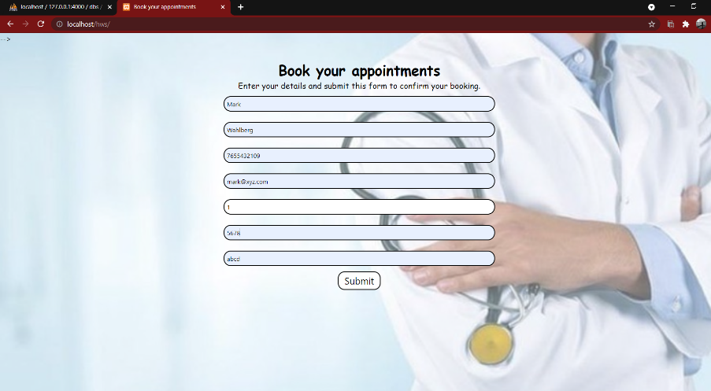

**Data stored after submitting the form:-**

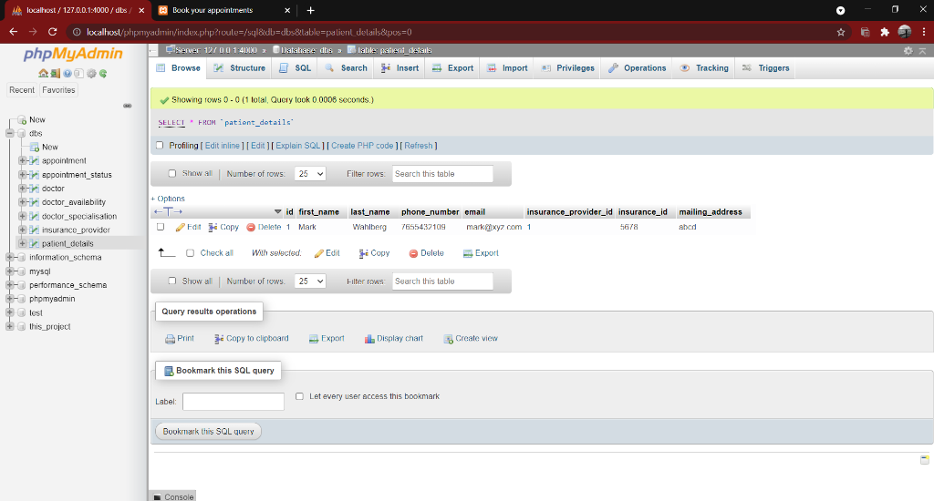

**Remark after submitting the form:-**

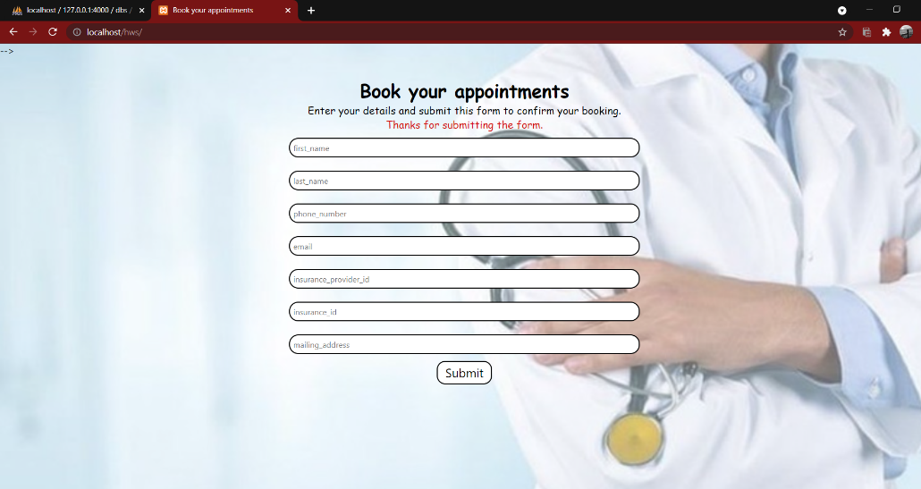

**Chapter 5**

**IMPLEMENTATION**

**Some executed queries :**

1)To display all confirmed appointments:-

select p.first\_name as 'Patient\_first\_name',p.last\_name as 'Patient\_last\_name',a.start\_time as 'Appointment\_start',a.end\_time as 'Appointment\_end',c.status as 'Appointment\_status',d.first\_name as 'Doctor\_first\_name',d.last\_name as 'Doctor\_last\_name' from appointment a,doctor d,patient\_details p,appointment\_status c

where a.doctor\_id=d.id and a.appointment\_status\_id=c.id and a.patient\_id=p.id and c.status='confirmed';

****

**2)To display get cancelled appoinments:-**

select p.first\_name as 'Patient\_first\_name',p.last\_name as 'Patient\_last\_name',a.start\_time as 'Appointment\_start',a.end\_time as 'Appointment\_end',c.status as 'Appointment\_status',d.first\_name as 'Doctor\_first\_name',d.last\_name as 'Doctor\_last\_name' from appointment a,doctor d,patient\_details p,appointment\_status c

where a.doctor\_id=d.id and a.appointment\_status\_id=c.id and a.patient\_id=p.id and c.status='cancelled';

****

**3)To display get pending appoinments:-**

select p.first\_name as 'Patient\_first\_name',p.last\_name as 'Patient\_last\_name',a.start\_time as 'Appointment\_start',a.end\_time as 'Appointment\_end',c.status as 'Appointment\_status',d.first\_name as 'Doctor\_first\_name',d.last\_name as 'Doctor\_last\_name' from appointment a,doctor d,patient\_details p,appointment\_status c

where a.doctor\_id=d.id and a.appointment\_status\_id=c.id and a.patient\_id=p.id and c.status='pending';

**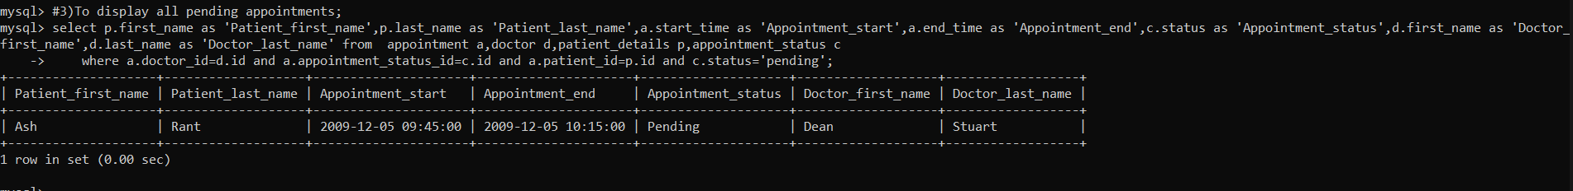**

**4) To display all doctor with their specialization**

select d.first\_name as 'Doctor\_first\_name',d.last\_name as 'Doctor\_last\_name',s.specialisation\_in as 'Specialisation' from (doctor d) join (doctor\_specialisation s) using (id);

****

**5) To display Doctor availability in ascending order of first\_name**

select d.first\_name as 'Doctor\_first\_name',d.last\_name as 'Doctor\_last\_name',s.specialisation\_in as 'Specialisation',a.starting\_time as 'Start time',a.ending\_time as 'End time'

from doctor d,doctor\_specialisation s,doctor\_availability a where d.specialisation\_id=s.id and a.doctor\_id=d.id order by d.first\_name;

****

**6) To display Doctor avialable more than once a week**

select d.first\_name as 'Doctor\_first\_name',d.last\_name as 'Doctor\_last\_name' from doctor d ,doctor\_availability a where d.id=a.doctor\_id group by d.first\_name having count(a.days\_in\_week)>1;

****

**7)To display Number of confirmed appointment a doctor has**

select d.first\_name as 'Doctor\_first\_name',d.last\_name as 'Doctor\_last\_name',count(d.first\_name) as 'Number of patients' from appointment a,doctor d,appointment\_status c,patient\_details p

where a.doctor\_id=d.id and a.appointment\_status\_id=c.id and a.patient\_id=p.id and c.status='confirmed' group by d.first\_name;

****

**8) To display Patients and their insurance providers**

select p.first\_name as 'Patient\_first\_name',p.last\_name as 'Patient\_last\_name',b.provider\_name,p.insurance\_id from patient\_details p,insurance\_provider b where p.insurance\_provider\_id=b.id;

****

**9) To display Number of patients per provider**

select a.provider\_name,count(p.first\_name) from patient\_details p,insurance\_provider a where p.insurance\_provider\_id=a.id group by provider\_name;

****

**10) To display Neurology doctor availability**

select d.first\_name as 'Doctor\_first\_name',d.last\_name as 'Doctor\_last\_name',a.starting\_time as 'Start time',a.ending\_time as 'End time' from doctor d,doctor\_specialisation b,doctor\_availability a

where d.specialisation\_id=b.id and a.doctor\_id=d.id and b.specialisation\_in='Neurology';

**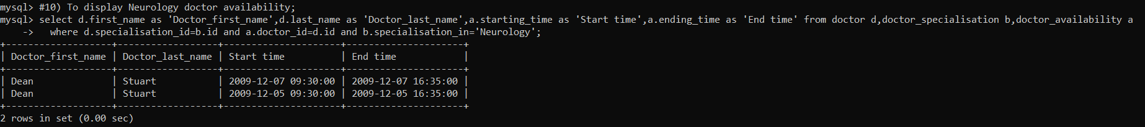**

**CONCLUSION**

As we have neared the end of our report, we would like to conclude that the database that we have created stores the details of the patients, doctors, and their appointments.

We created our projected using database as databases support good data access because: large volumes of data can be stored in one place. Multiple users can read and modify the data at the same time. Databases are searchable and sortable, so the data you need can be found quick and easily.

**FUTURE ENHANCEMENT**

The improvement is that the system should be flexible enough for further modifications. Considering this as an important factor, the system is designed in such a way that future enhancements can be added without affecting the system which is presently developed.

We can enhance our project by connecting our whole database by connecting to the front end and make it a useful tool in booking an appointment. We can also make an appointment booking app with some major modifications to our database and the front end, thus helping the users to book their appointment with doctors online

**REFERENCES**

The references that we have taken information as well as inspiration are from Wikipedia and YouTube

**THANK YOU!!!**

